BOARD OF INTERMEDIATE & SECONDARY EDUCATION SUKKUR-SINDH

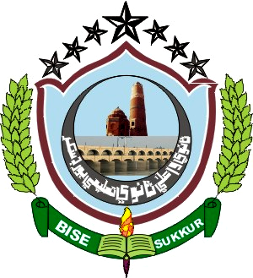
NO:BISE/HSC(S)/SUK/-2834 Dated: 04-10-2019

Website: www.bisesuksindh.edu.pk
Email: mail@bisesuksindh.edu.pk

NOTIFICATION

The Positions secured by the candidates at the Higher Secondary Certificate Part-II (Class XII) Annual Examination-2019, (Home Economics Group), held by the Board of Intermediate & Secondary Education, Sukkur, are declared provisionally, as under:-

- FIRST THREE CANDIDATES in order of Merit

Sr# | Seat  No: | Photograph | Name in Full (With Institution) | POSITION | MARKS  OBTAINED | Grade
01 | 125002 | 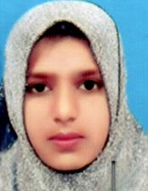 | Rizwana  D/o  Rahim Dino, Ibupoto  Govt: College For Women, Khairpur | 1st | 952 | A
02 | 125001 | 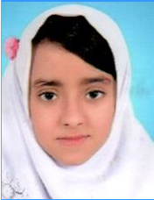 | Noor Fatima  D/o  Kaleemullah, Shaikh  Govt: College For Women, Khairpur | 2nd | 928 | A
03 | 124508 | 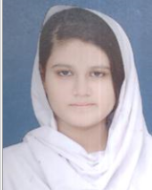 | Iqra Urooj  D/o  Imtiaz Baig, Mughal  Govt: Girls Degree College, Sukkur | 3rd | 795 | B

The Board reserves the right of rectifying the mistakes/errors and omissions in the Positions / Results at any time, on the basis of original record of the Board.

( Waqar Hussain Jokhio ) ( Ghulam Qadir Channa) ( Abdul Sami Soomro )
Asstt: Controller of Examinations Dy: Controller of Examinations Controller of Examinations
(HSC-Secret) (Secret)

- Zafar Lashari

125001 2ND | 125002 1ST | 124508 3RD

